Understanding your salary: A guide for Tufts AS&E tenure-line faculty

The purpose of this guide is to help tenure-line faculty in AS&E understand their salaries and salary adjustments. This report is based on data shared with AAUP by the Tufts administration as well as the deans of AS&E but should not be construed as official policy. Note that much of the report is specific to A&S reflecting a longer history of data sharing.

Understanding AY 2025 salaries in AS&E
As part of the annual AAUP salary report, a regression analysis was conducted using existing salary data for faculty in AS&E from AY 2025 to see how much of the variation in salary can be explained by factors like race, gender, field, rank, years in rank.
This analysis found no statistically significant differences in salary by race or gender as all p-values exceeded the 0.05 significance threshold. It found statistically significant salary differences by field: with engineering professors making the most followed by social sciences, natural sciences, and then humanities. The model that includes individual characteristics and field explains a substantial share of salary variance (about 60%).
You can plug in your own information into the below spreadsheet (double click and a new file will open) to see what the model would predict your salary should be, based on people with similar characteristics .
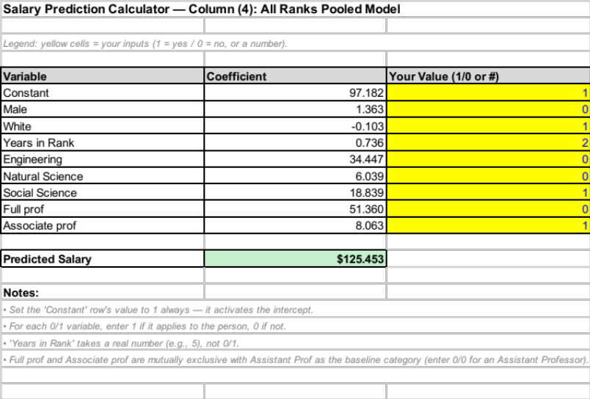

Salary trends over time in A&S
The AAUP report also examined how salaries in A&S have (not) kept pace with inflation. In the plot below, the reduction in real (inflation-adjusted) salary is plotted in terms of 1000s of dollars over time. You can see that in 2025, A&S salaries were about $12,500 lower, in real dollars, than they were in 2016. Inflation adjustments calculated using Boston-Cambridge-Newton, MA-NH Area CPI.
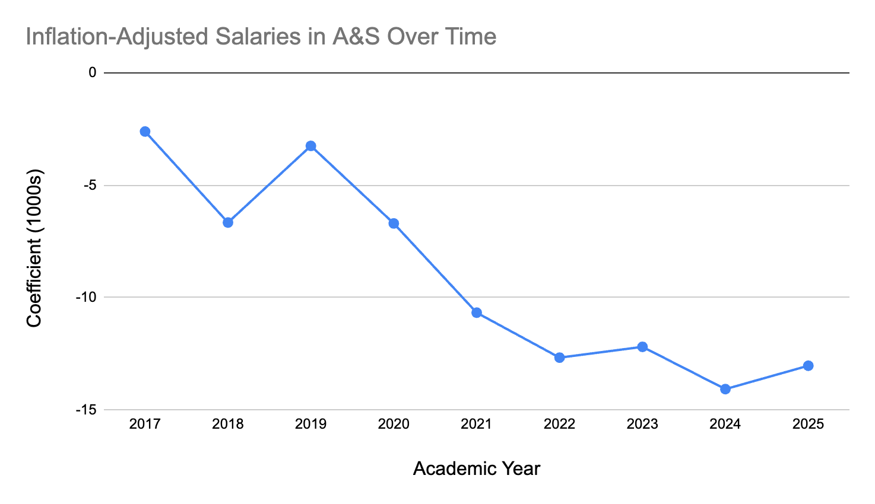

Process for determining raises in A&S for AY 2026
The process for determining salary adjustments in A&S for AY 2026 involved field-specific benchmarking and prioritized adjustments to individual faculty based on a combination of distance from benchmark and performance. It's important to recall that this process was initiated in response to faculty who presented data—including past AAUP reports—to press for the need to address salaries in A&S.
1. Benchmarking
- Average target “benchmark” salaries are calculated for each rank using data from four Boston-area schools: Boston University, Boston College, Brandeis, and Northeastern. The resulting benchmark averages are higher than current Tufts salaries for all ranks in A&S, which has motivated the salary adjustment plan that is currently being implemented. Note that no specific benchmark values have been shared.
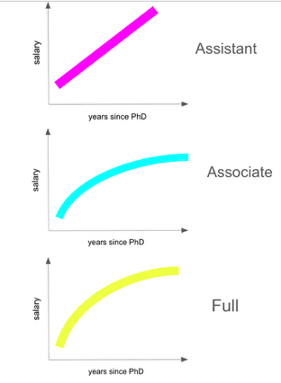
- For each rank, a curve is created to model how salary could grow over time according to the following assumptions:
  - Assistant professors: linear growth, ending at tenure
  - Associate professors: quadratic (reflects assumption that productivity growth slows with years in rank)
  - Full professors: quadratic (similar logic to associate curve)

- Curves are shifted up or down based on CUPA-HR national discipline data — generally up for STEM fields, no shift or down shifts for social sciences and down for humanities fields.
2. Individual Salary Adjustments for AY 2026
- For any individual, AY 2025 salary, years since PhD, and rank can be plotted against the discipline-adjusted curve, landing them in one of three zones (see Figure below):
  - At/above benchmark (+ or - 5% of the curve)
  - Below benchmark (below 5%)
  - Very below benchmark
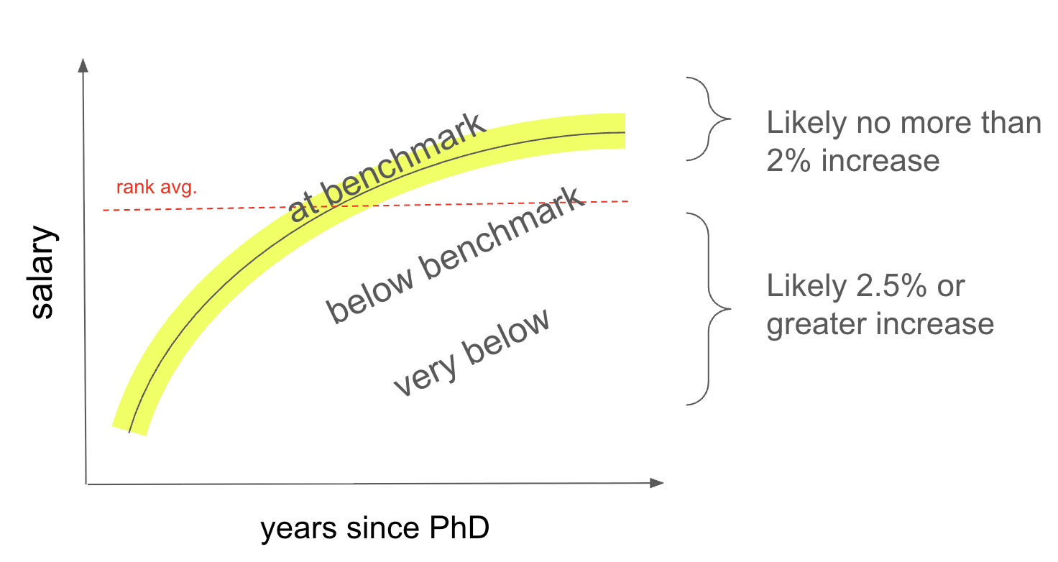
- Department chairs reviewed faculty performance and gave input to deans.
- Deans combined chair input, the benchmarking data, and their own judgment to propose specific raise percentages.
  - Those who were at or above threshold were unlikely to receive more than 2%
  - Those below threshold were likely to receive 2.5% or higher depending on both distance from benchmark and performance assessment.
- Chairs met with deans again to review the proposed percentages and suggest minor tweaks. The finalized percentages were written into the salary letters you received.
- Importantly, all raise money now comes from one combined pool — previously split into separate "merit" and "equity and excellence" pools. This means raise averages and ranges can and did differ by department. For example, raises were highest on average in the STEM disciplines this year as faculty in those departments were furthest from benchmarks.

What Happens Next
The stated goal is to bring all A&S faculty salaries within 5% of their benchmark target within 3–5 years though President Kumar stated a hope that the process may be competed sooner (1-2 years) at the first AS&E meeting of the AY 2026.

Note that Economics is an outlier, with salaries much higher than other social science disciplines, affecting salary predictions within the social sciences.
Again, Economics follows a different pattern that other social sciences with CUPA-HR values that shift benchmark curves upwards compared to most other social sciences where curves are either not shifted or downshifted.

